**Question bank_BEEE**

1. Write notes on
2. Flux
3. Flux density
4. MMF
5. Magnetic field Intensity
6. Reluctance
7. What do you mean by Analogous Electric circuit? Justify your answer by Force Voltage and Force Current analogy.
8. A Rectangular shaped core is made of mild steel plate 15 mm x 20 mm cross-section. The mean length of magnetic path is 18 cm. The coil has 300 turns and current is 0.7A. Calculate- (a) Magnetic Flux (b) Reluctance.
9. A coil of 500 turn having resistance of 20 ohm is wound uniformly on an iron ring of mean circumference of 50 cm with cross section area of 4 cm2 is connected to 24 V dc supply, assume relative permeability is 800. Find (i) MMF (ii) Magnetizing force (iii) Total flux
10. An Iron Ring has a cross section area is 2 cm2 and a mean diameter of 20 cm. An air gap of 0.4 mm has been cut across the section of the ring. The ring is wound with a coil of 300 turns. The total magnetic flux is 0.20 mWB. The relative permeability of iron is 1000. Determine the current flowing through the coil.

1. A Rectangular iron core with a cut size of 2 cm as shown in given figure, details are as follows – mean length of magnetic circuit= 50 cm, cross section area= 3 cm x 3 cm, Relative permeability= 1000, No of turns in each coil= 200, Current in each coil= 5A.

Calculate Flux in air gap.

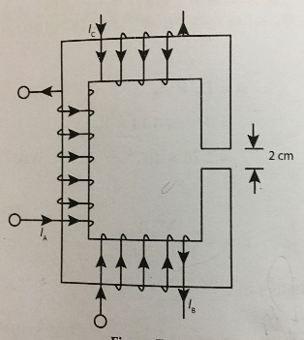

1. Write notes on
2. Wave form
3. Active Power
4. Peak Factor
5. Form factor
6. Average Value
7. Drive the Average and RMS value for a sinusoidal AC Signal by Graphical or Analytical method.
8. Draw pure resistive circuit diagram, Draw is waveform and Phasor diagram also drive formula for its active power.
9. With the help of pure capacitive circuit diagram, draw its waveform and Phasor diagram also drive formula for its active power.
10. Draw pure inductive circuit diagram, Draw is waveform and Phasor diagram also drive formula for its active power.
11. Drive Resonance frequency and Q factor formula for Series Resonance RLC circuit also draw its phasor diagram.
12. Find the current I and voltage V in R1 using nodal analysis method in circuit of figure below.

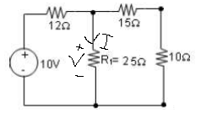

14.Notes on

1. Active and Passive circuit
2. Unilateral and Bilateral circuits
3. Node and Branch
4. Mesh and Loop

15, An alternating current i is given by I=50 sin314t

. Find the following:

1. Time Period
2. The maximum value of current
3. The instantaneous value when t=4 ms

17. Define p-n junction diode, explain its forward and reverse biased operation with diagram.

18. Define Transducers. Write its classification and characteristics in detail.

19. Write notes on biosensors for environmental monitoring.

20. Find current IL in the given circuit using Thevenin’s Theorem

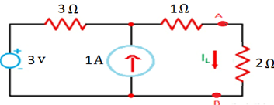

21. For the rectangular iron core shown has a relative permeability of 1500. If the current in the coil is 1A, determine the number of coil turns needed to produce a magnetic flux of 3mWb in the core.



23. A capacitor which has an internal resistance of 10Ω and a capacitance value of 100uF is connected to a supply voltage given as V(t) = 100 sin (314t). Calculate the current flowing into the capacitor. Also construct a voltage triangle showing the individual voltage drops.

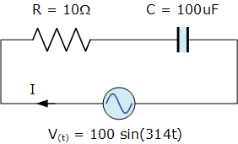

24. What is the sensor? What are the criteria to choose sensor? Explain different types of sensors with their functions and Applications.

25. A 110V ac supply is applied to a coil of 1.0H inductance and 1.0 Ω resistance connected in series with 8.6 µF capacitor. Calculate

1. Impedance
2. Current
3. Phase angle between current and voltage
4. Power Factor
5. Power consumed

26. Define Rectifier. Explain the working principle of Bridge full wave rectifier with neat diagram. Also write its ripple factor and efficiency formula with their ideal values.

27. Find the current I1 and I2 in the circuit given below using mesh current analysis

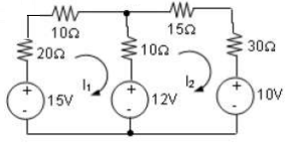

28. A two-legged core is shown in the figure. The winding on the left leg (*N*1) has 600 turns, and the winding on the right (*N*2) has 200 turns. The coils are wound in the directions shown in the figure. If the dimensions are as shown, then what flux will be produced by currents *i*1 = 0.5 A and *i*2 =1.0 A? Assume *μr* =1000 and constant.

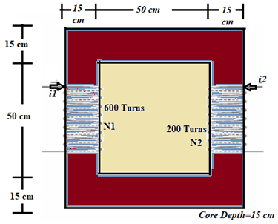

29. Write notes on

1. Wave form
2. Active Power
3. Peak Factor
4. Form factor

30. Draw and explain the forward and reverse biased p-n junction V-I characteristics curve.

31. Differentiate between Sensors and Transducers. What are the criteria to choose sensors?

32. State Norton’s Theorem. List the steps for obtaining Norton’s Equivalent Circuit. Compare Norton’s and Thevenin’s Equivalent Circuit.

33. A solenoid is constructed of sheet steel and its magnetic flux density is to be B=0.1 Tesla when its field strength is H=100 AT/m. Determine the relative permeability of this core also calculate the current required to produce magnetic flux density when the average radius is 0.01m and the cross-sectional radius is 0.02m and coil has 500 turns.

34. What are the Biosensors? Describe its main components, working principle and applications in healthcare.

35. Why Transistor is so called Bipolar junction Transistor and keeping base very thin and light dopped. Explain working of npn / pnd transistor.

36. Drive Resonance frequency and Q factor formula for Series Resonance RLC circuit also draw its phasor diagram.

37. Define significance of three terminals of bipolar junction transistor, with neat diagram explain common emitter, common base transistor configuration with its current amplification factor and output current equation.

38. What is the resonance circuit? Give the equation for series and parallel resonance and define the terms.

39. A sinusoidal alternating current of frequency 25 HZ has a maximum value of 100 A. How will it take for the current to attain the value of 20 A?

40. What will be the value of the supply voltage if its frequency is 50Hz.

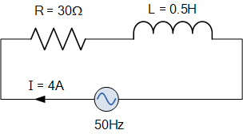

41. Distinguish between time and frequency –domain relationship. Take the example of R-L series circuit excited by sinusoidal current.

42. Sketch the variation of impedance/admittance with frequency in RLC series and parallel resonant circuit.

43. A resultant current wave is made up of two components: direct current 10 A and sinusoidal alternating current of 50 HZ with peak value of 10A. Draw the resultant current wave.

44.Apply Thevenin’s theorem to find *Vo* in the circuit of

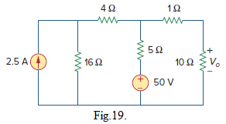

45. For the circuit in figure-20, determine the value of R for maximum power dissipation in it and the value of power dissipation.

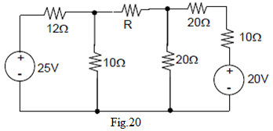

46. Obtain the Thevenin equivalent at terminals *a*-*b* of the circuit shown in Fig.

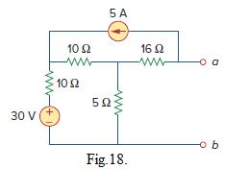

**47.** Using superposition theorem find out the potential difference across 20 ohm resistor.

15Ω

15Ω

10Ω

figure-3

**-**

10V

+

20Ω

**-**

12V

+

10Ω

**-**

15V

+

I

48. Obtain Norton equivalent circuit of the circuit shown in Fig.15. at terminals *a*-*b*.

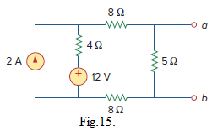

49. Apply the superposition principle to the circuit shown in fig.14, and find *i*.

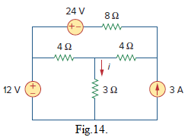

**50.** Using Thevenin’s theorem find out the current trough the 4Ω resistor for the circuit shown below.

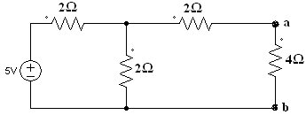

51. Find current IX in each of the network given in Fig1. using current division rule**.**

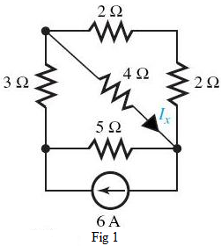

52.Determine the number of branches and nodes in the circuit shown in Fig. 4. Identify which elements are in series and which are in parallel.

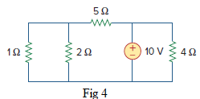

53.Find all the branch currents and branch voltages in the circuit shown in Fig.5

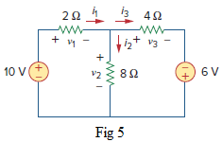

54.Write Kirchhoff’s Voltage and current Law with examples.

55. Using **mesh** current analysis find the current through 12Ω resistor for the circuit in figure.

10Ω

15Ω

20Ω

figure-

**-**

10V

+

12Ω

**-**

15V

+

30Ω

**-**

12V

+

15Ω

**-**

+

10V

I1

I2

I3

56. Using any of the laws and/or theorems find out the **Current** through 15Ω resistor as shown in figure-

**-**

10Ω

12Ω

20Ω

15Ω

12V

+

40Ω

figure-